THE UNIVERSITY OF DODOMA



COURSE: OBJECT ORIENTED PROGRAMMING IN JAVA

INSTRUCTOR: MR EVERYJUSTUS BARONGO

COURSE CODE: CP 215

INDIVISUAL ASSIGNMENT

NAME: ANUARI IDDI ISSA

REG NO: T/UDOM/2020/00345

COURSE BCS CE

**Question 01.**

In diagram, indicate the relationship between Java code, JDBC API and Database Driver.

JDBC stand for Java Database Connectivity is the Java API that manages connecting to a database, executing the queries and commands and handling the result sets obtained from the database. JDBC provides the mechanics of the java applications communicating with a database. The JDBC provide two layers which are JDBC API and JDBC driver.

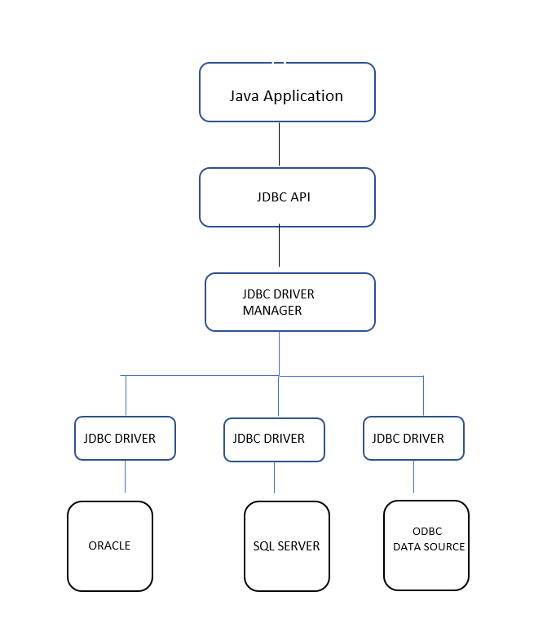

**Question 02.**

Itemize requirements necessary to use JDBC and any DBMS.

Select DBMS as Mysql

IDE as Netbeans

Connector as mysql-connector-java-8.0.28

**Question 03.**

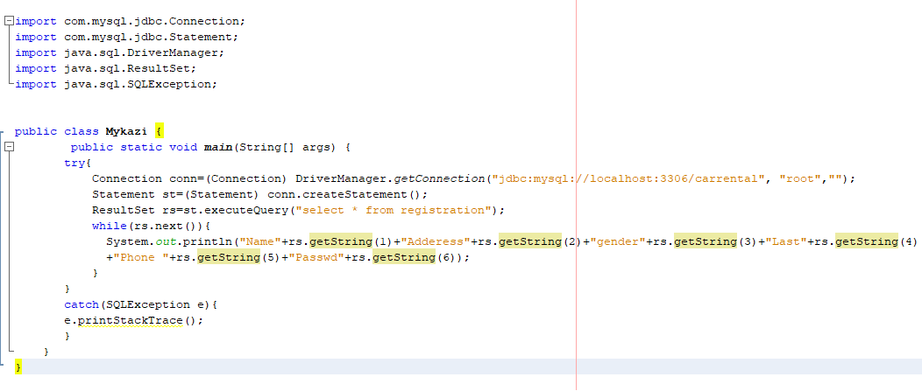

**Question 05.**

CREATE DATABASE StudentData;

CREATE TABLE student(

regNo int (50) NOT NULL AUTO_INCREMENT PRIMARY KEY,

names VARCHAR(50) NOT NULL,

Address VARCHAR(50) NULL,

);

CREATE TABLE course(

courseID int (20) NOT NULL AUTO_INCREMENT PRIMARY KEY,

course_code VARCHAR(10) NOT NULL,

course_name VARCHAR(200) NOT NULL,

studID int(10)

);

QN6

**The java program for insert data into the database.**

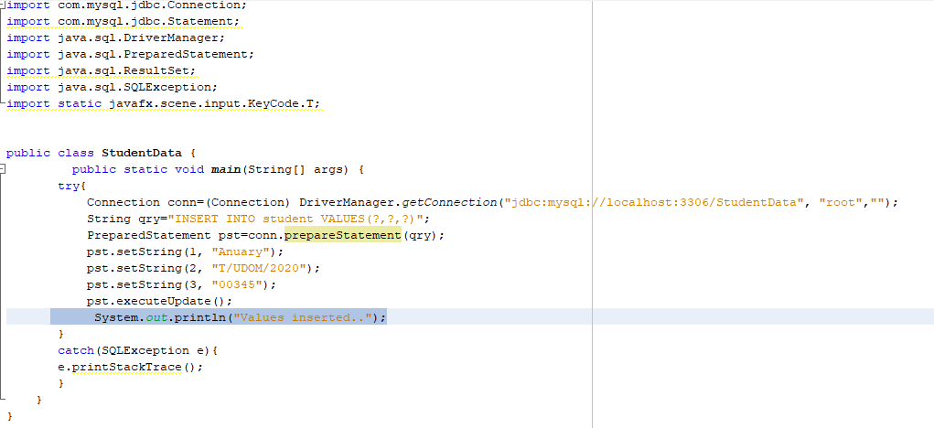

**Java program to select data into the database**

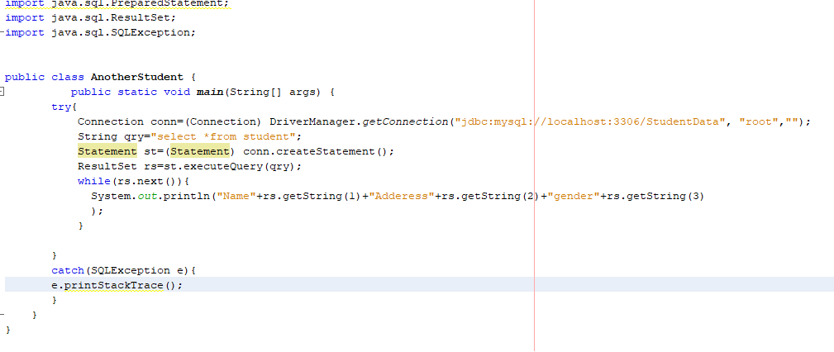

**Java program delete data into the database**

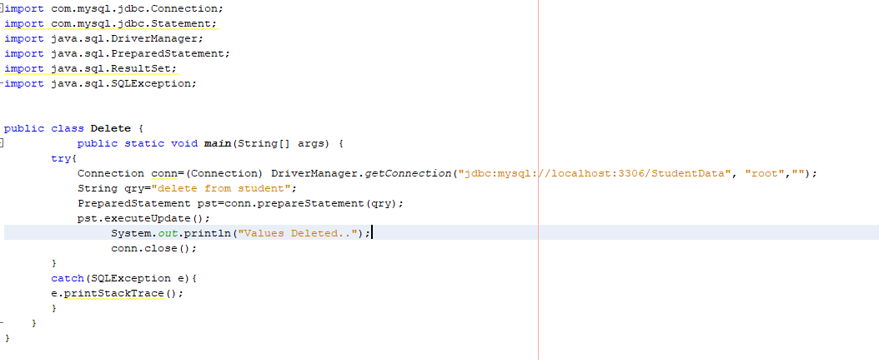

QUESTION 7

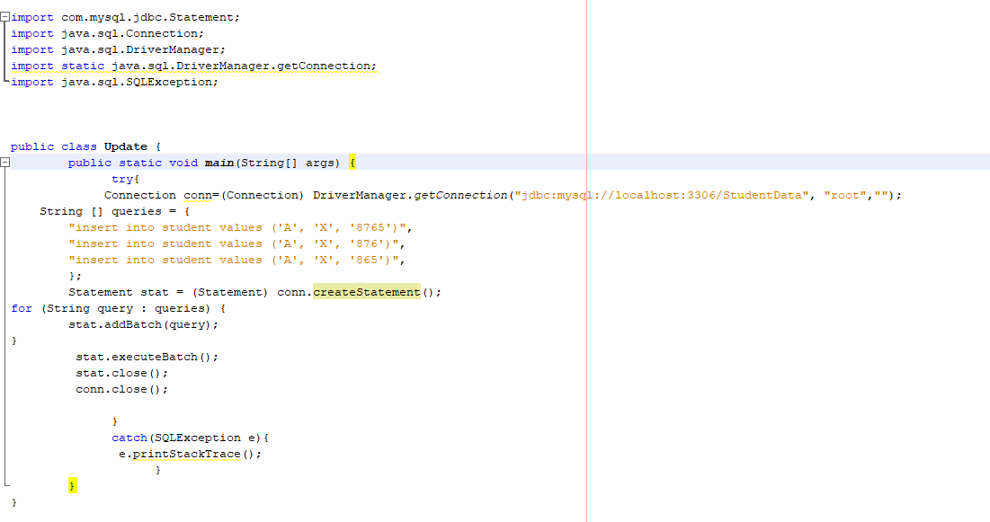

mport com.mysql.jdbc.Statement;

import java.sql.Connection;

import java.sql.DriverManager;

import static java.sql.DriverManager.getConnection;

import java.sql.SQLException;

public class Update {

public static void main(String[] args) {

try{

Connection conn=(Connection) DriverManager.getConnection("jdbc:mysql://localhost:3306/StudentData", "root","");

String [] queries = {

"insert into student values ('A', 'X', '8765')",

"insert into student values ('A', 'X', '876')",

"insert into student values ('A', 'X', '865')",

};

Statement stat = (Statement) conn.createStatement();

for (String query : queries) {

stat.addBatch(query);

}

stat.executeBatch();

stat.close();

conn.close();

}

catch(SQLException e){

e.printStackTrace();

}

}

}